**Google Cloud Natural Language API:**

* **Offers Entity Analysis, Sentiment Analysis, Syntax Analysis, Entity Sentiment Analysis, Content Classification.**
* **Provides pre-trained models and options to create custom categories**
* **Strong integration with other Google cloud services**
* **Well documented and widely used.**
* **usage of the Natural Language is calculated in terms of “units,” where each** [**document**](https://cloud.google.com/natural-language/docs/reference/rest/v1beta2/documents) **sent to the API for analysis is at least one unit. Documents that have more than 1,000 Unicode characters (including whitespace characters and any markup characters such as HTML or XML tags) are considered as multiple units, one unit per 1,000 characters.**
* **For example, if you send three requests to the Natural Language that contain 800, 1,500, and 600 characters respectively, you are charged for four units: one for the first request (800), two for the second request (1,500), and one for the third request (600).**
* **Prices for usage of the Natural Language are computed monthly based on which feature of the API you used, and how many units are evaluated using those features. The table below provides the price per 1,000 units based on the total number of units analyzed during the billing month**

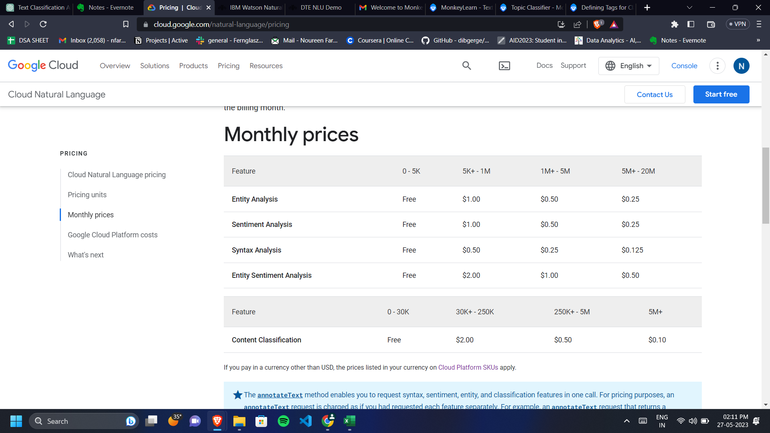

**Reviews - didnt categorize many texts even though it was pretty clear**

**IBM Watson Natural Language Understanding:**

* **Offers Entity Recognition, Sentiment Analysis, Concept and Keyword Extraction, Emotion Analysis, Categories and Classification, Syntax Analysis**
* **Offers customizable categories and industry-specific models**
* **Powerful language understanding capabilities**
* **Strong integration with IBM Watson ecosystem**

## **Pricing plans**

|  | Lite | Standard |
| --- | --- | --- |
| **Usage** |  |  |
| **1-250K items/month** | **First 30K Free** | **USD 0.003/item** |
| **250K-5M items/month** | **N/A** | **USD 0.001/item** |
| **5M+ items/month** | **N/A** | **USD 0.0002/item** |
| **Instance fee (USD/month)** | **N/A** | **---** |
| **Additional language (USD/month)** | **N/A** | **--** |
| **Custom entities & relations model trained with WKS (USD/model/month)** | **1 free custom model** | **USD 800** |
| **Custom classication model (USD/model/month)** | * **1 free custom model** | * **USD 25** |

**Review - categorization 9/10 , also does subcatogaries**

**Monkey Learn:**

* **Offers Text Classification, Sentiment Analysis, Keyword Extraction.**
* **Allows to integrate NLP functionalities into your application or workflows. The API supports multiple languages and provides a simple interface**
* **Can create custom classifiers. We can upload labeled training data and train models specific to our domain and industry**
* 